We consider a portfolio fully invested in four risky assets (A, B, C, D). Denoted by wi the weight invested in asset i, i = A, B, C, D.

Since all of the weight must be invested in the assets, the proportion of wealth invested in the various assets must equal 100% of wealth. This leads to the budget equation expresses in matrix notation **wT1N =** 1.

a)





b)

Our objective function is the portfolio variance, and we will minimize it with respect to the portfolio weights. Actually, instead of using the portfolio variance, we will use a factor of ½ to ease our calculations. Since the factor is positive, it does not affect the value of the optimal vector of the weights w*.

$\frac{min}{w}\frac{1}{2}$ wT∑w*

We have two constraint:

First constraint is: portfolio return must be equal to prespectified level m= 0.1 as;

µπ = µTw* = m = 0.1

The second constraint on the weights called ‘budget equation’. The sum of all the weights must necessary equal 1.. Since there is no risk – free assets, our welth must be entirely invested in a combination of the four assets.

wT**1** = 1

The problem is an optimization with equality constraints. Therefore it can be solved using the method of Langrange.

L(w,λ,γ) = $\frac{1}{2}$ wT∑w* + λ(m - µTw) + γ(1 – **1**Tw)

After solving first order condition and second order condition, we reached the optimal weight vector w*.

w* = ∑-1 (λµ + γ**1**)



 

The optimal asset allocation to obtain a return m = 10% is given by;



Threfore, the portfolio return µπ can be written as

µπ = µTw*

and the portfolio variance and portfolio standard deviation are given by,

σπ2 = wT ∑ w, σπ =



We have used the explicit resolution of optimazation problem to compute the vector of weights of an efficent portfolio with the following constraints;



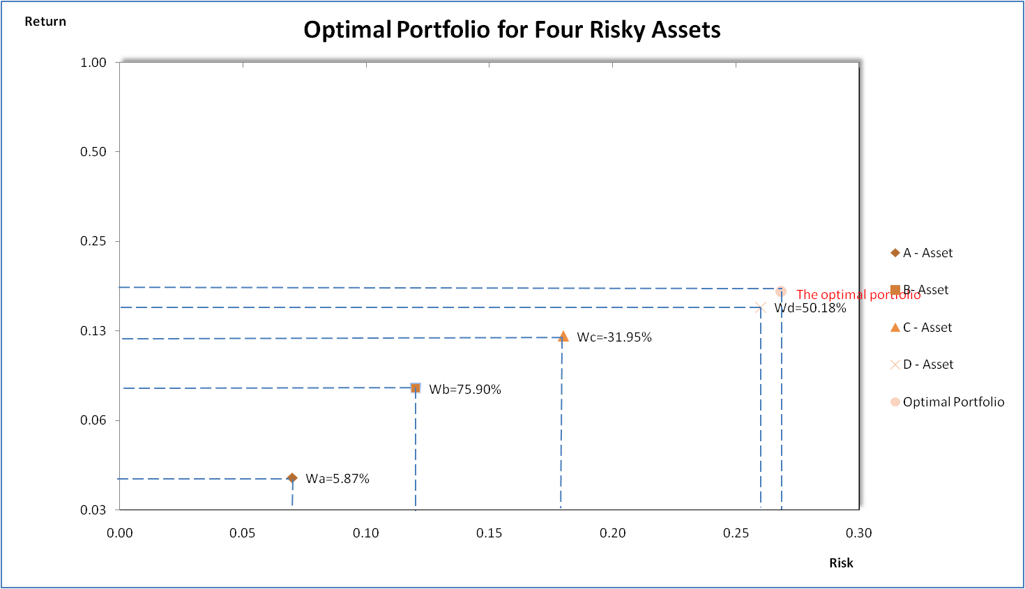

c)

Minimum risk portfolios are also called efficient and the locus of these portfolios is called the efficient frontier. Thus portfolios with the best combinations of the weights lie along the efficient frontier, where a target return is achieved with minimum risk.

We have the following objective function

$\frac{min}{w}\frac{1}{2}$ wT∑w*

With a badget constraint

wT**1** = 1

Currently the portfolio weights must sum to one ‘budget equation’, but are unconstrained by any further conditions, hence the terminology ‘unconstrained frontier’. Since we have one constraint, we introduce one lagrange multiplier γ and define the langrange function L(w,γ) as

L(w,γ) = $\frac{1}{2}$ wT∑w* + γ(1 – **1**Tw)

 

The global minimum varience portfolio’s assets allocation is given by

wg=





Its return is

mg = 

and its standard deviation is equal to

σg = = 

